Grading and hours
Throughout the semester, you have the opportunity to provide the student with feedback and see their progress toward their rotation goals. You may find discussing progress towards goals with students each week or making notes will help you keep track.
We use Typhon for tracking hours and final evaluations for the student (instructions below). The clinic director typically sends an email reminder one week prior to the due date and a second reminder the week of the due date.
As part of the evaluation, you will have an opportunity to rate the student in areas specific to your placement. You will rate the student on a scale of 1 to 5 (shown below). Additionally, you may offer individualized feedback to identify their strengths and areas for improvement. There is also an opportunity to mark the student as Satisfactory or Unsatisfactory.

Typhon Hours
This guide instructs off-site preceptors to effectively navigate and utilize the Typhon Clock Hours System. It includes instructions for logging into the system, reviewing and approving case logs using the "detail" and "highlight" menus, and reviewing and approving time logs.
Logging In
- Navigate to https://www.typhongroup.net/ahst/preceptor/login.asp?facility=9103
- Click "Log In"
- Click "Preceptor/EASI"
- Click the "Account Number" field and type "9103"
- Select "Preceptor/Supervisor". Enter your email and password and click "Log In"
Highlights (bulk approve)
- Choose “Case Log Highlights”
- Select your student’s name
- Choose any date in the month you wish to review/approve. This will need to be done for each month the student was with you.
- Click the box at “Show entire MONTH of logs that includes this date (first to last day of the month)”
- Click “Apply Filters”
- This will open up all encounters for the month selected
- At the top of the table with all encounters, you will see this 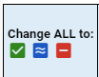
- Select the green check mark to change all to “Approved”
- A dialog box will pop up asking, “Are you sure you want to change all to approved?” Select OK
- Do the same procedure for each month the student was with you.
- You can email or call me with your questions (Kellsie-busho@uiowa.edu).

Detail (individual case approvals)
- Select case log details
- Select the case ID you wish to approve (it will have a blue box next to it signifying pending)
- You can review the information
- At the top of the page, you have the option to click “edit/comment”
- Change approval status to approve (or not approved and add comments if incorrect)

Evaluation Overview
Satisfactory/Unsatisfactory Ratings:
Satisfactory – Student demonstrates expected skills in the area based on clinical experiences to date and is expected to be able to function as an effective, well-educated and competent clinician in this area when the student begins independent practice as a professional in the field.

Unsatisfactory – Student does not demonstrate expected skills in this area based on clinical experiences to date and is not expected to be able to function as an effective, well-educated and competent clinician in this area when the student begins independent practice as a professional in the field.

Competency Ratings:
- Competency absent - Student is unable to demonstrate skill. Modeling and repeated verbal/written instruction do not result in an improvement of the skill.

- Competency emerging - Student is unable to demonstrate skill without modeling and direct verbal instruction from the clinical instructor. Student does not independently recognize strengths and weaknesses, but understands them if pointed out by clinical instructor. Modeling and direct verbal instruction result in an improvement of the skill.

- Competency present - Student is able to demonstrate skill; however, skill needs further development. Clinical instructor monitoring is required except for routine cases. The clinical instructor is present most of the time to provide verbal guidance without modeling. Student independently recognizes strengths and weaknesses, but requires input from the clinical instructor to make appropriate clinical decisions. Modeling and verbal/written instruction result in generalization of the skill.

- Competency developed – Student demonstrates skill consistently. Monitoring by the clinical instructor may be necessary sometimes, but only in difficult or uncommon cases. Student understands strengths and weaknesses to the extent that the student can use critical thinking to make appropriate clinical decisions and knows when to seek input from the clinical instructor.

- Competency well developed – Student demonstrates skill consistently across patients and situations. Student uses critical thinking to make clinical decisions and can articulate them to the clinical instructor who is used as a consultant.

Evaluations on Typhon
Here is a link to the Typhon website:
https://www.typhongroup.net/ahst/preceptor/login.asp?facility=9103

Step 1. When you log in you will see the home screen below. Click on “My Evaluations”
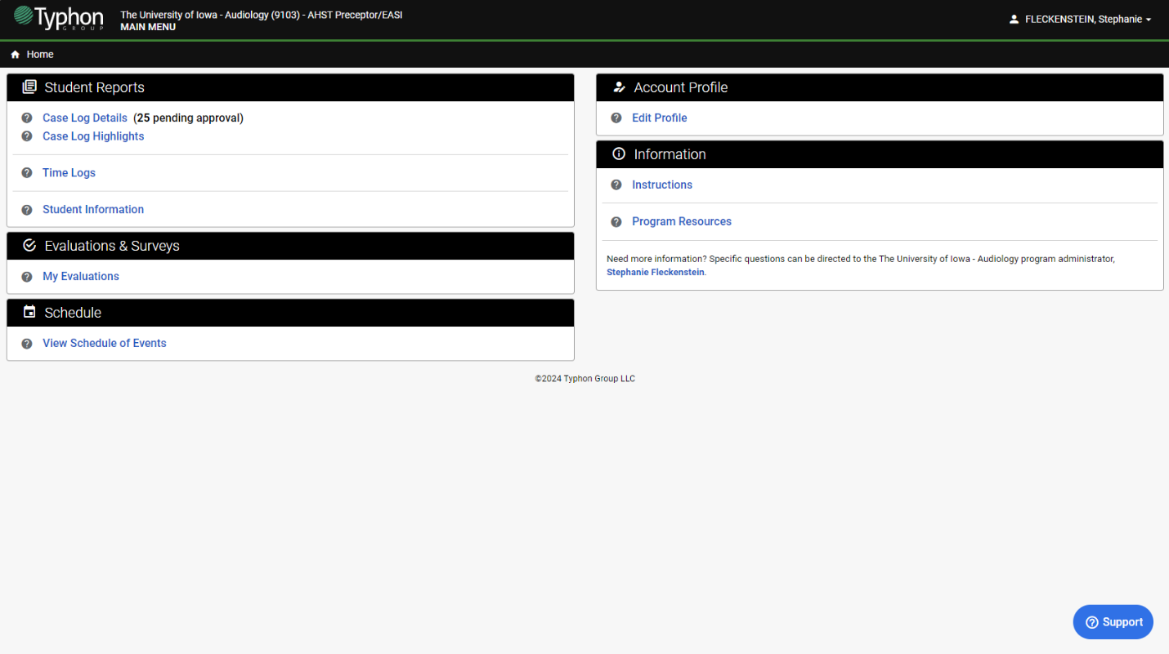

Step 2. Click on “UI AuD Eval of Student by Clinical Instructor”
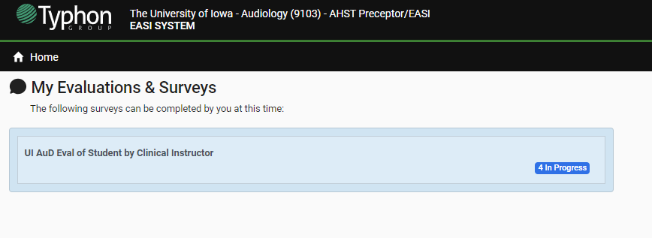

Step 3. Click on “New Survey.” Select any date during the evaluation period and the student you wish to evaluate. Then click on “Begin New Survey.”
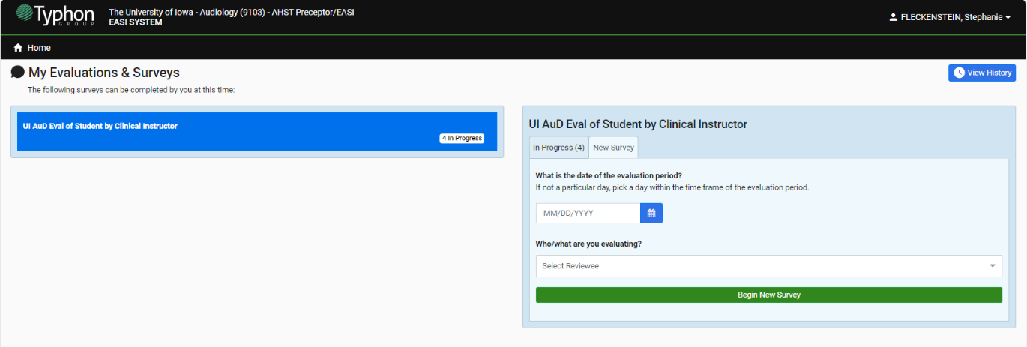

Step 4. Complete the survey/evaluation. Be sure to fill in the information about student, clinical instructor, clinical site at the top of the survey then rate the student and add any feedback comments you feel would be of benefit to the student’s learning and growth in clinical skills. For any skill area you did not observe, leave blank.

From the home screen, you can choose the blue “Support” button on the bottom right if you have questions. Typhon is very responsive and helpful. You can also email or call me with your questions (kellsie-busho@uiowa.edu).

